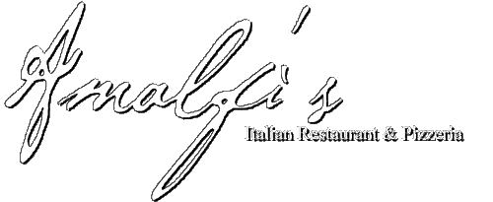
LUNCH SPECIALS

Eggplant Parmigiana + Salad …………...$7.99
½ Chicken Parmigiana + Salad……….....$7.99
½ Parmigiana Alfredo W/Penne……......$8.25
+Salad
Saltimbocca……………………………..…$7.99
(Prosciutto Ham, Sliced Eggplant, Sliced Tomato, & Fresh Sliced Mozzarella)
+French Fries

Gluten Free Options
10” Pizza, 1 Topping … ……………….$10.99
Flatbread Turkey or Ham & Cheese Sub..$8.99
(Comes W/Lettuce, tomato, onion, mayo, oil & vinegar) + French Fries
Gluten Free Healthy Select…………….$8.95
Grilled Chicken, Broccoli, & Mushrooms Finished in our Cherry Tomato Sauce over our Gluten Free Pasta
Chocolate Tart. ………………………....$4.95

Monday -Friday
(Until 2:30 pm)
Served with Drink
Grilled Chicken Salad…………………..$ 6.25
Blackened Chicken Salad………………$ 6.95
Small Pizza, 1 Topping……………...…$14.99
+ 2 Small Salads
1 Slice ,1 Topping + Small Salad…….$ 5.25
2 Slices, 1 Topping…………………..…$ 4.99
1 Slice, 1 Topping + 5 wings…………..$ 6.45
Soup and Small Salad……………….....$ 5.25
8” Philly Steak Sub + Fries…………….$ 7.25
8” Tuna Sub +Fries……………………..$ 6.75
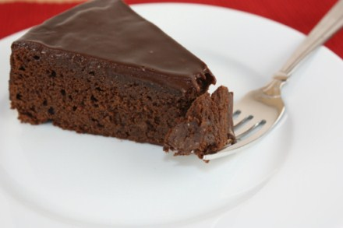
Lasagna + Small Salad…………………$ 7.95
Manicotti +Small Salad………………...$ 7.95
Stuffed Shells + Small Salad…………...$ 7. 95
Baked Ziti + Small Salad……………….$ 7.95
Spaghetti ……………………………...…$7.75
W/Tomato or Meat Sauce + Small Salad
Continued――――――――――――――――――→

